

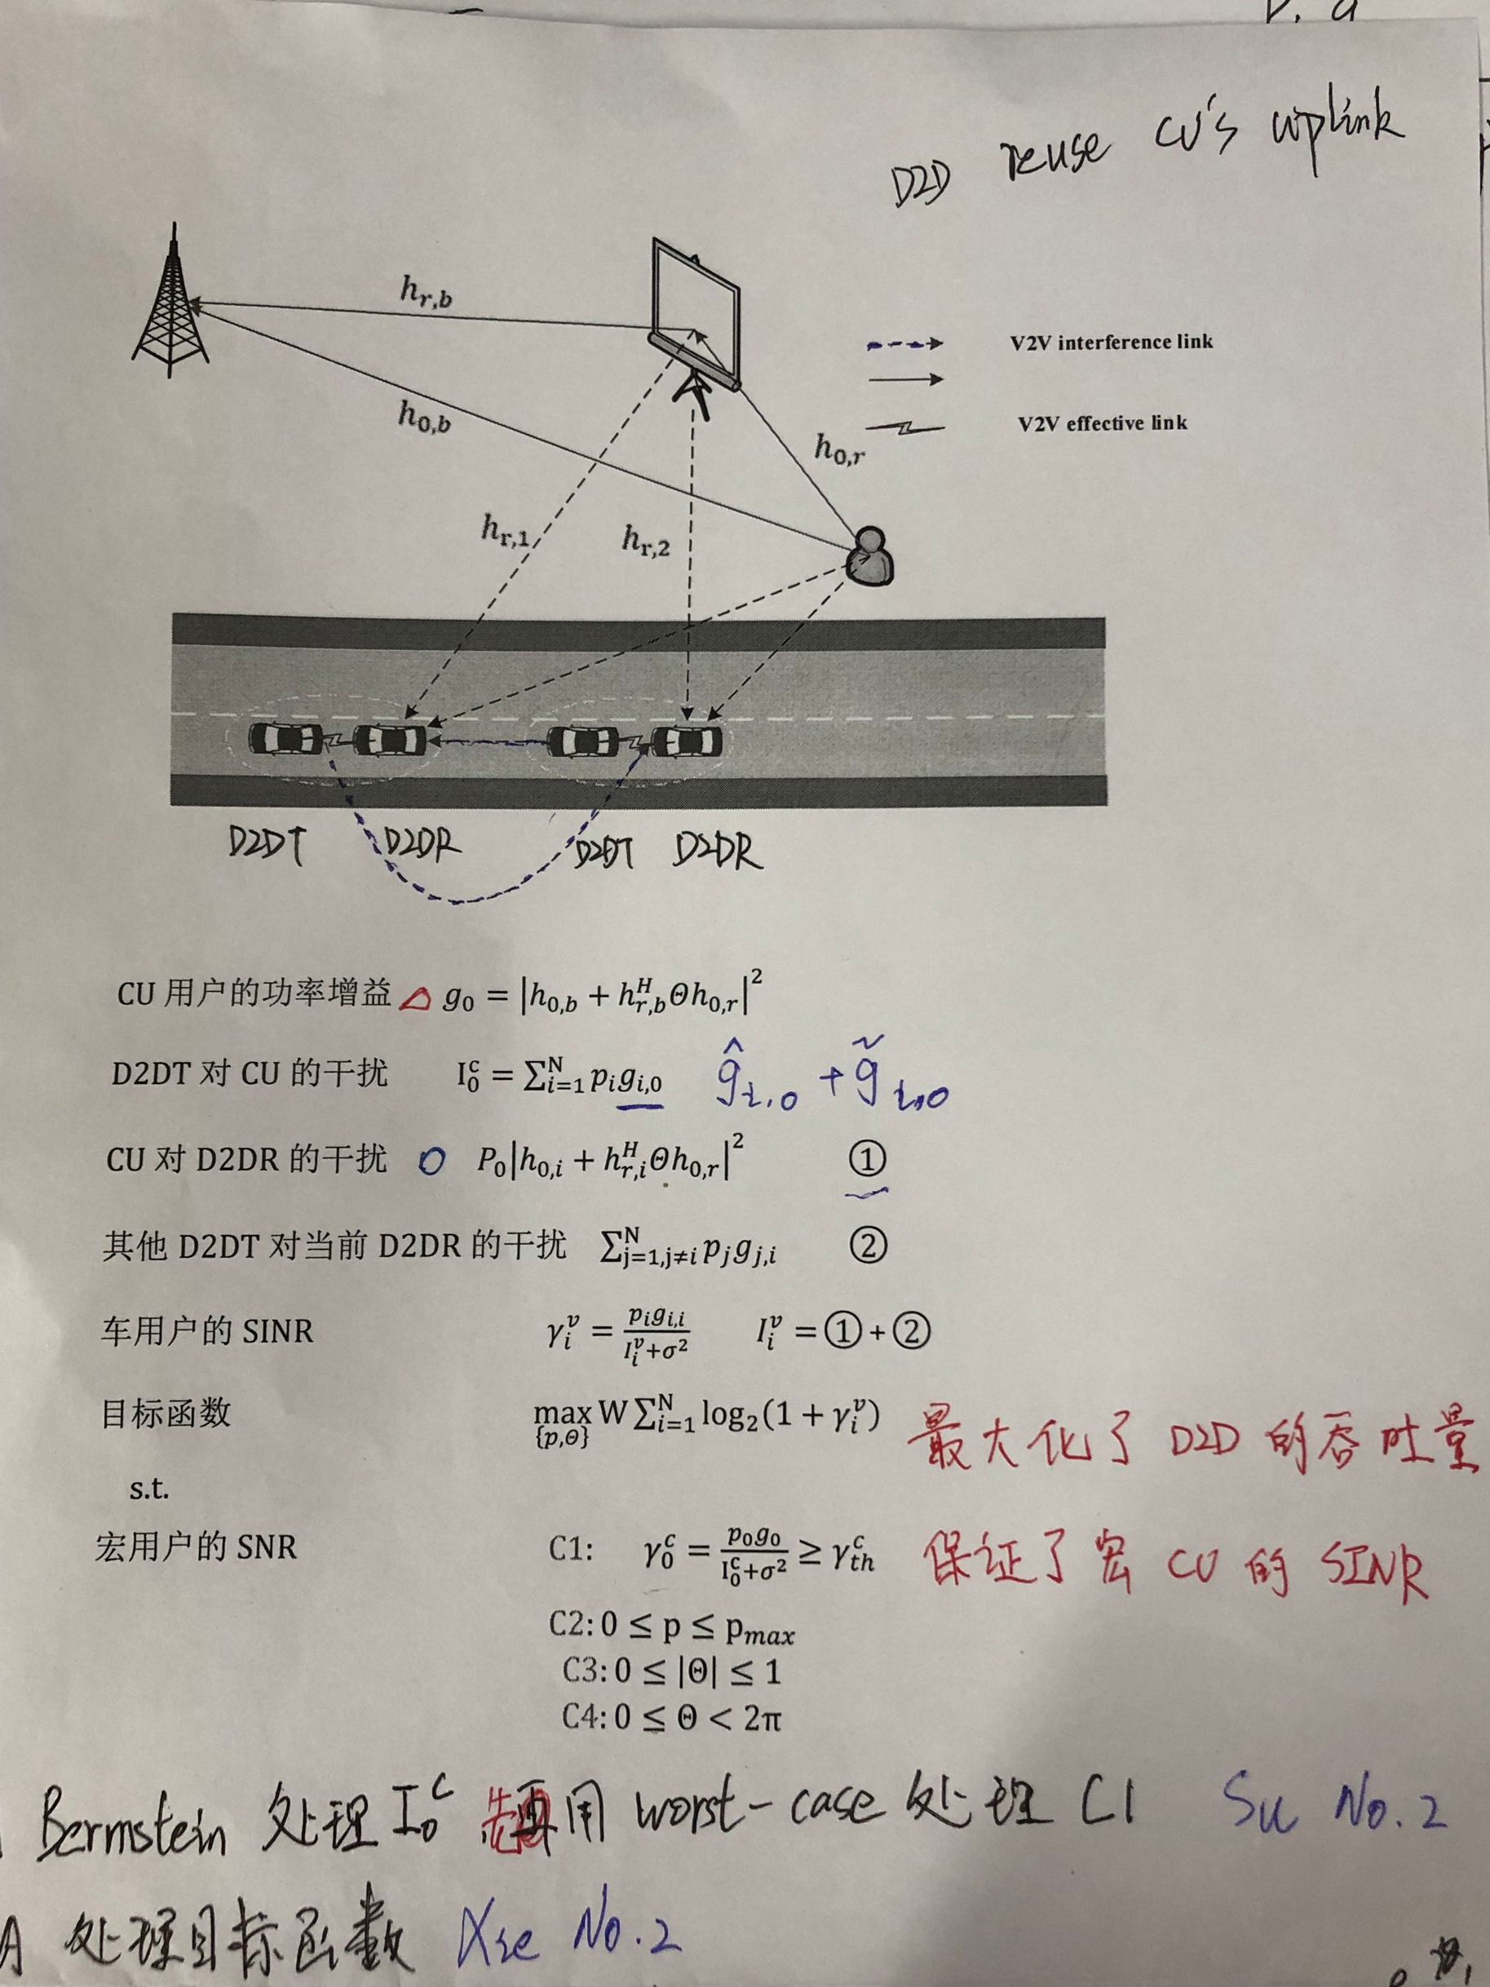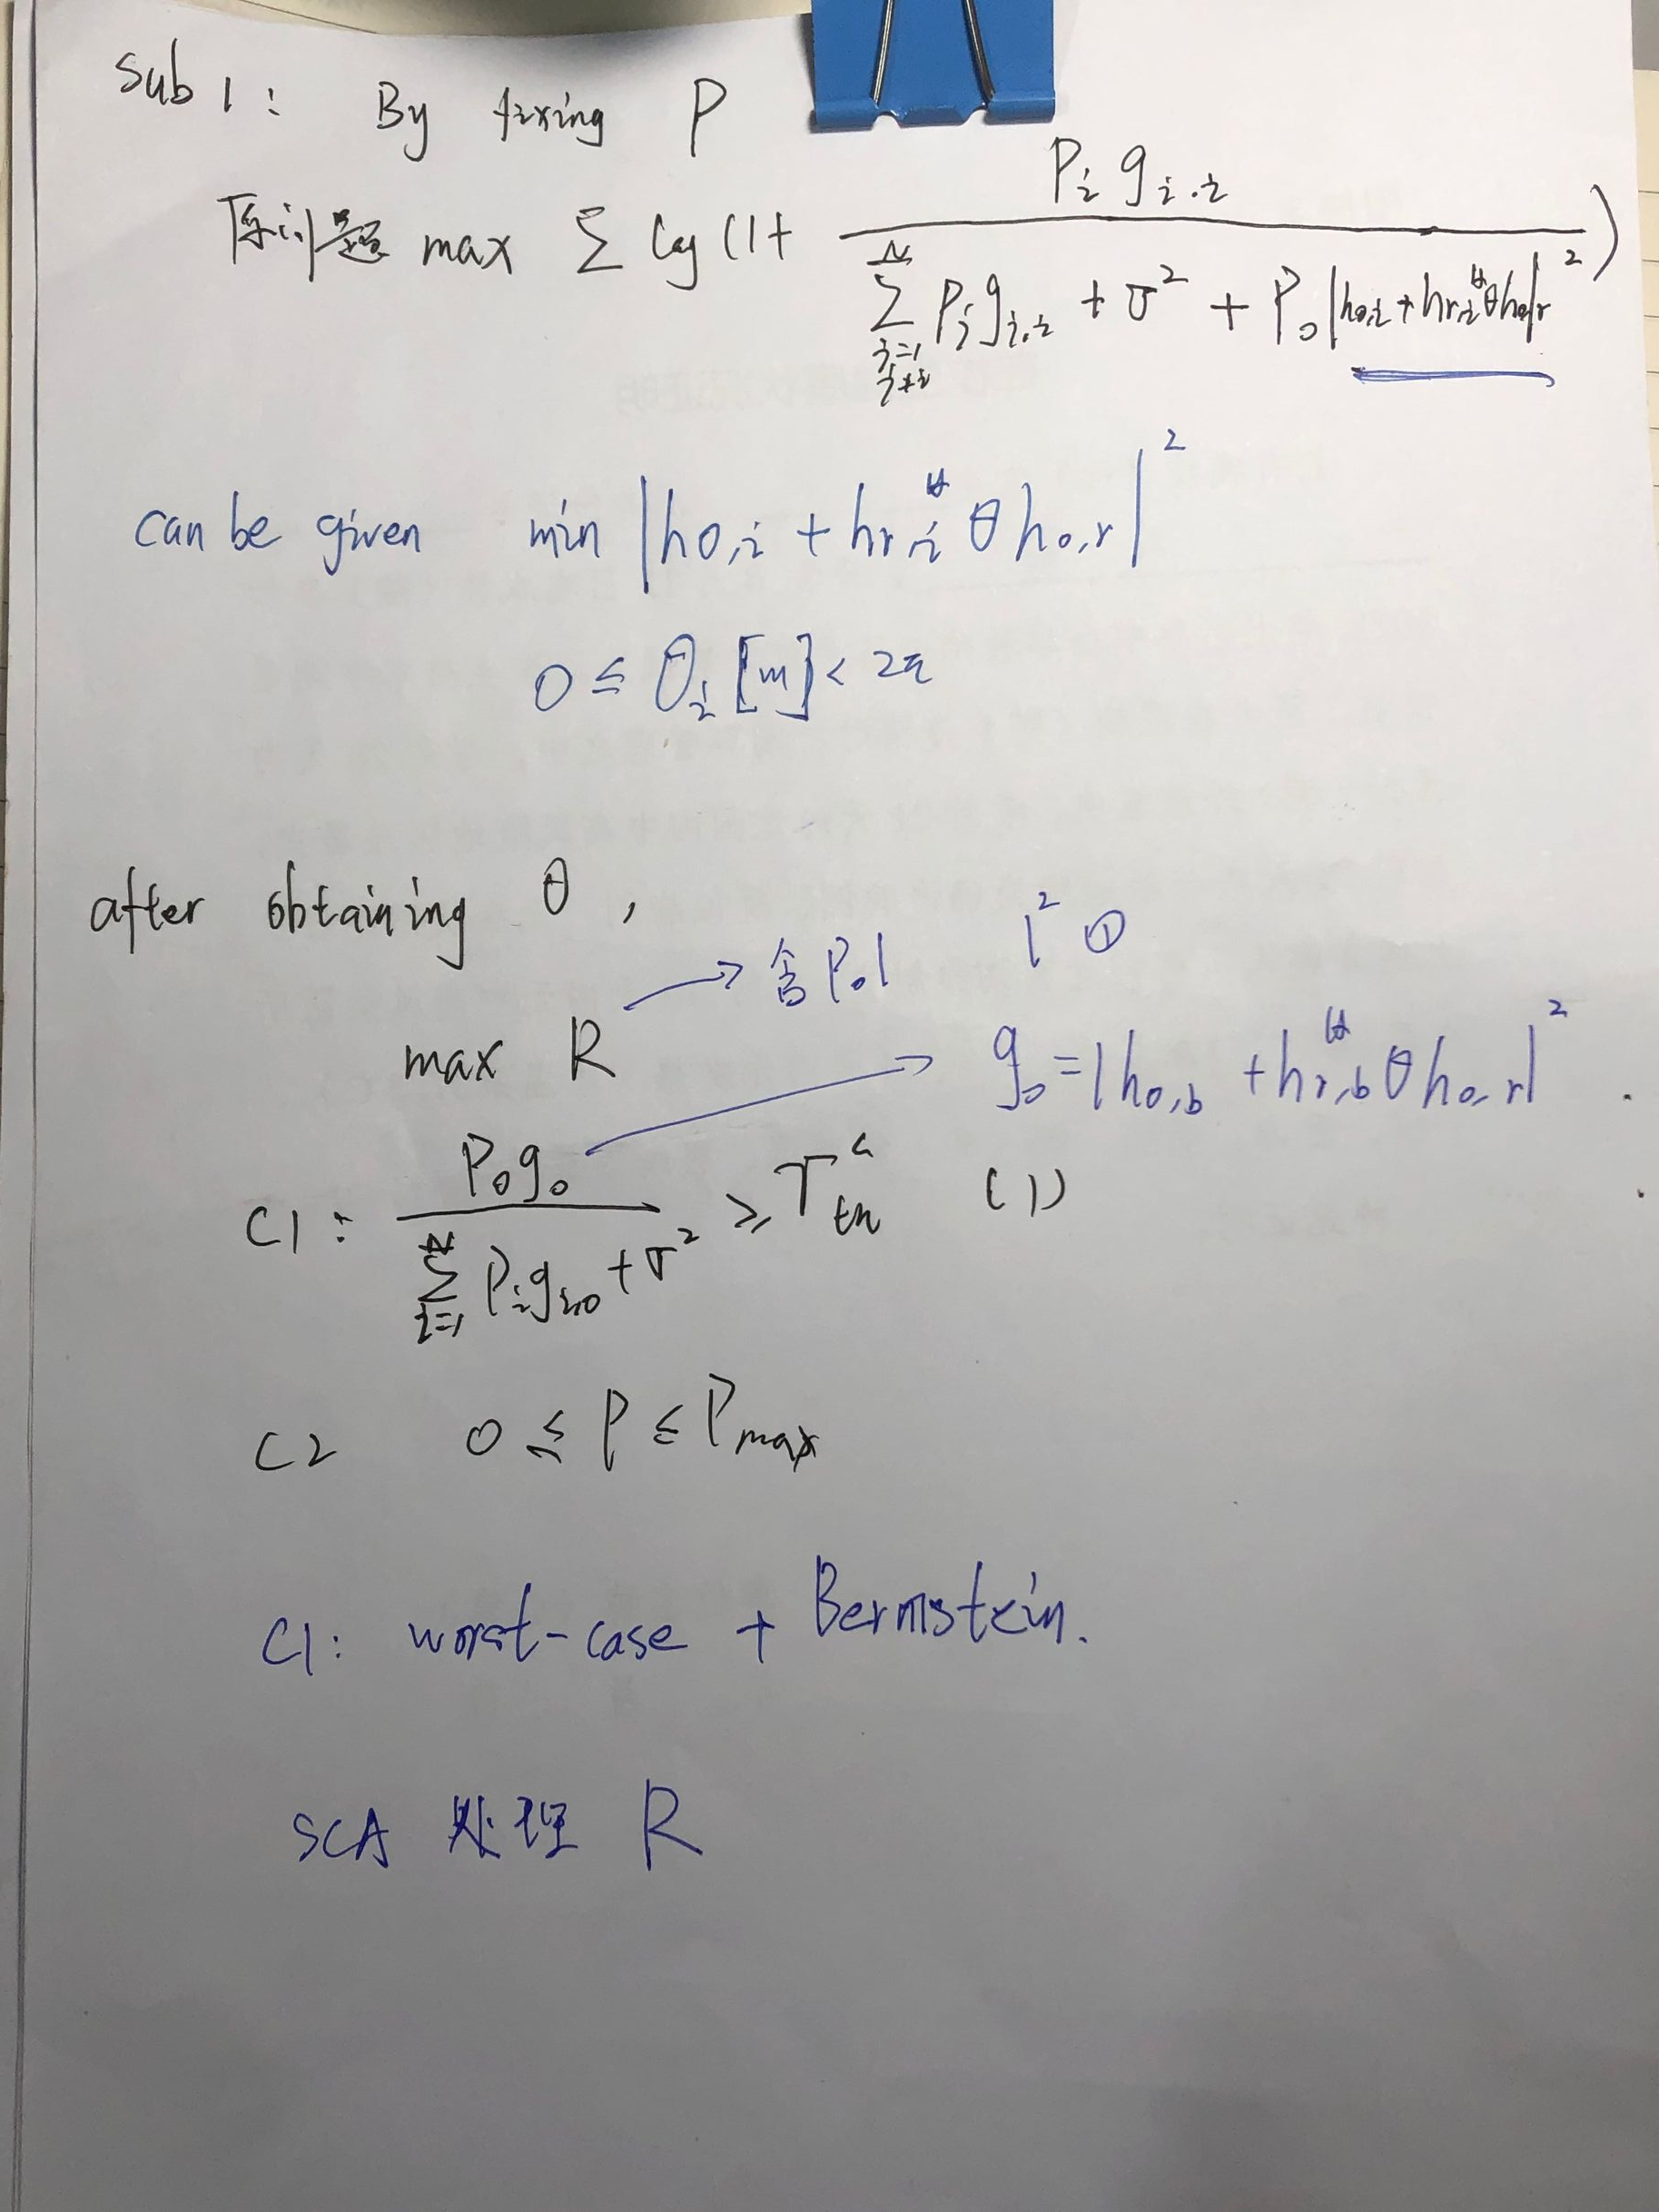

PERFECT SCI OF CU-BS AND CU-D2DR

$g_{0}={\left|h_{r,b}^{H}Θh_{0,r}+h_{0,b}\right|}^{2}$

rewritten as ${\left|h_{r,b}^{H}Θh_{0,r}+h_{0,b}\right|}^{2}={\left|zΦ+h_{0,b}\right|}^{2}$

where $z=h_{r,b}^{H}diag\left\{h_{0,r}\right\}$

$$Φ={\left(β_{1}e^{jθ_{1}},…,β_{N}e^{jθ_{M}}\right)}^{T}$$

Slack variables $κ=Re\left(zΦ+h_{0,b}\right)$

$$ξ=Im\left(zΦ+h_{b,m}\right)$$

$$κ^{2}+ξ^{2}={\left|zΦ+h_{b,m}\right|}^{2}$$

Similarly $P_{0}{\left|h_{r,ⅈ}^{H}Θh_{0,r}+h_{0,i}\right|}^{2}$

rewritten as ${\left|h_{r,ⅈ}^{H}Θh_{0,r}+h_{0,i}\right|}^{2}={\left|\tilde{z}Φ+h_{0,i}\right|}^{2}$

where $\tilde{z}=h_{r,ⅈ}^{H}diag\left(h_{0,i}\right)$

$$Φ={\left(β_{1}e^{jθ_{1}},…,β_{N}e^{jθ_{M}}\right)}^{T}$$

Slack variables $η=\left\{η_{i}=Re\left(\tilde{z}Φ+h_{0,i}\right),∀i\right\}$

$$ω=\left\{ω_{i}=Im\left(\tilde{z}Φ+h_{0,i}\right),∀i\right\}$$

$$\tilde{z}=h_{r,ⅈ}^{H}diag\left(h_{0,i}\right)$$

$$η_{i}^{2}+ω_{i}^{2}={\left|\tilde{z}Φ+h_{0,i}\right|}^{2}$$